**Program 1**

**CIS 5740: Web Programming**

**Bernice Templeman**

**Exercise 3-1: Install and use NetBeans IDE**

This exercise makes sure that you can use NetBeans to run a web application on a Tomcat server.

**Test NetBeans and Tomcat**

1. Create a new Project for a web application named testApp, and save it in the ex_starts directory. I created the testApp:

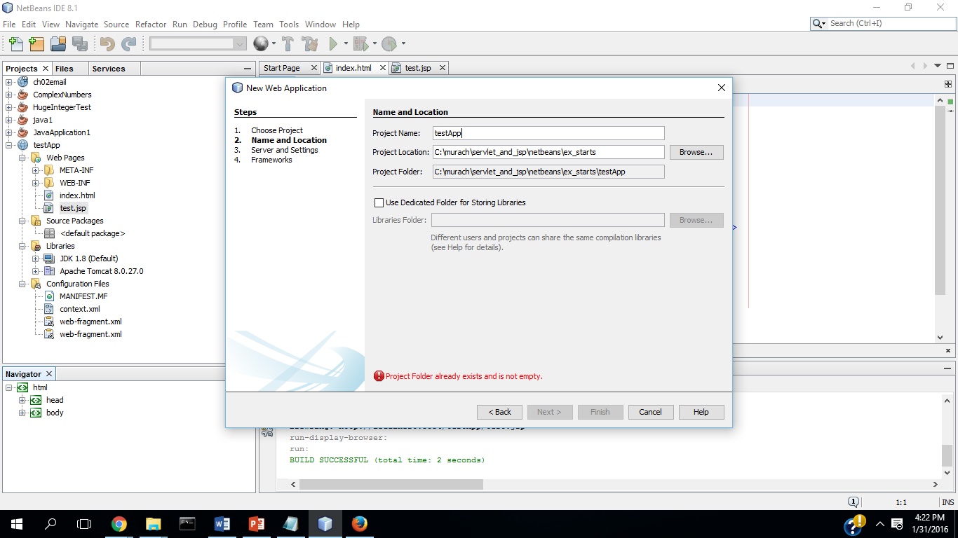

1. Make sure this project uses the Tomcat server.

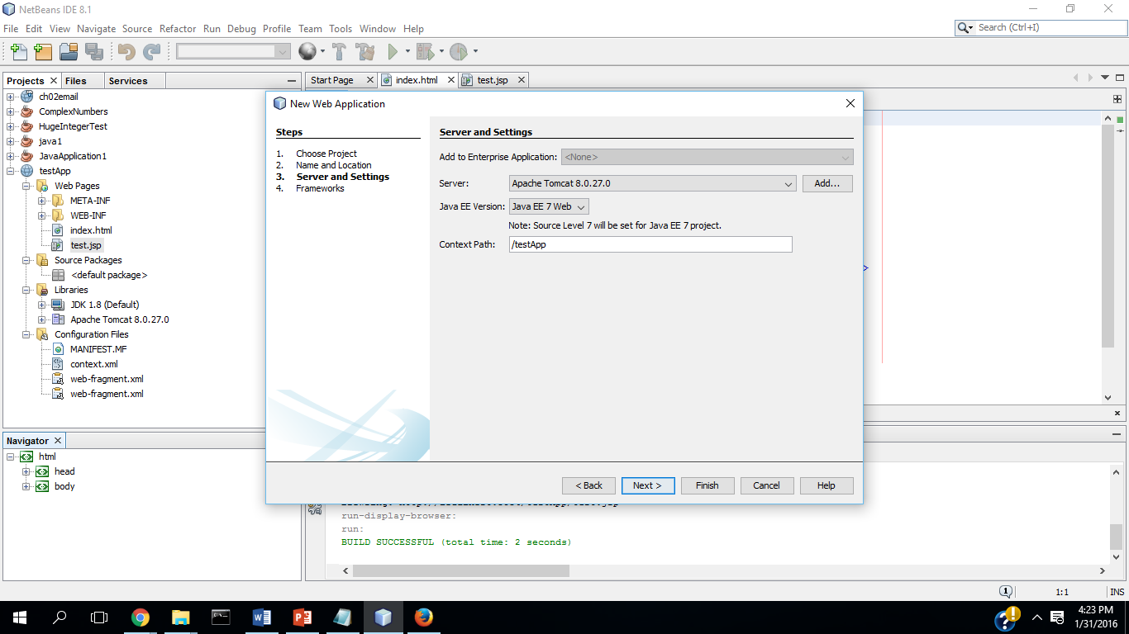

1. Use the Projects window to review the folders and files for the testApp project.

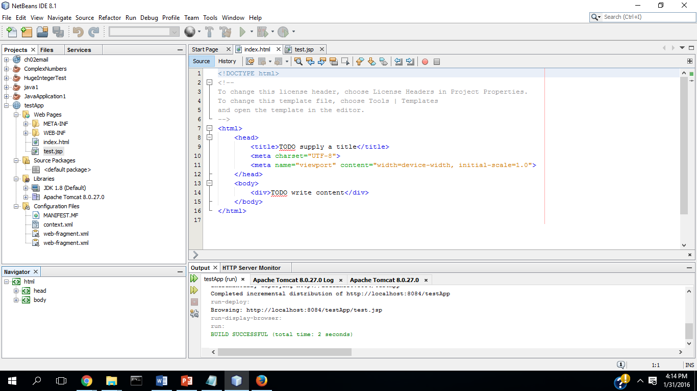

1. Run the testApp web application, and review the information that’s in the NetBeans Output window.

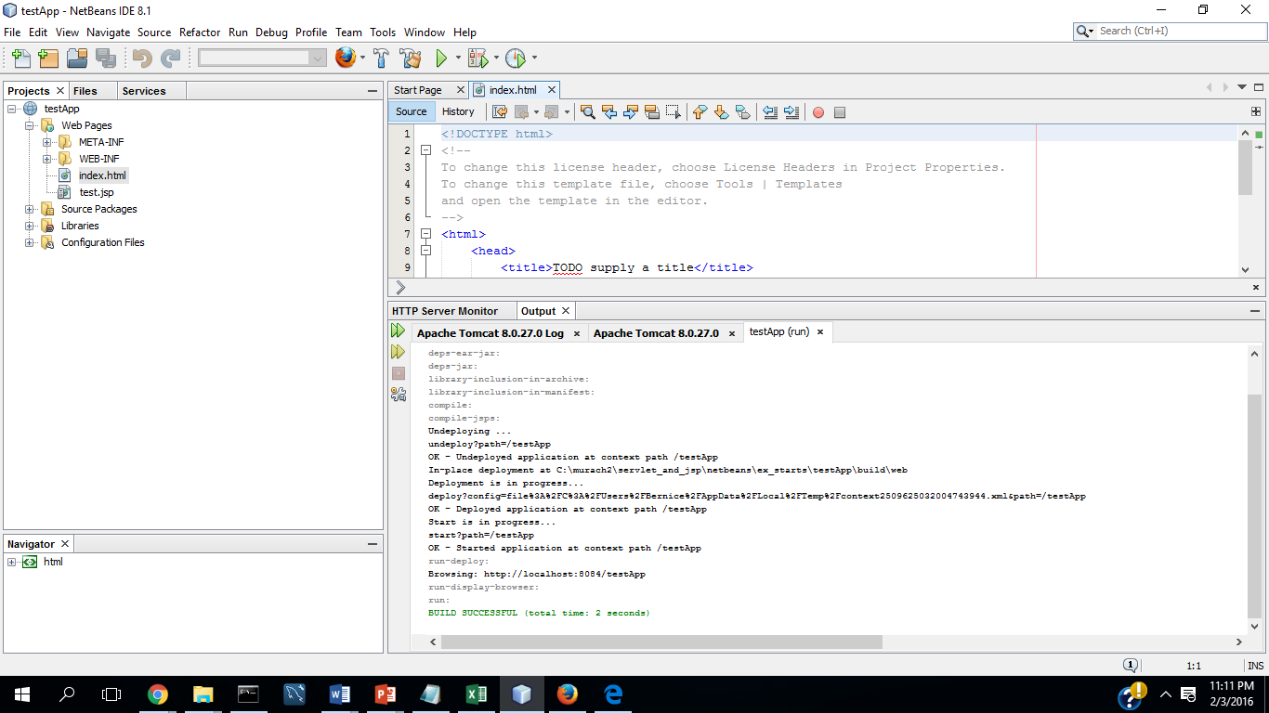

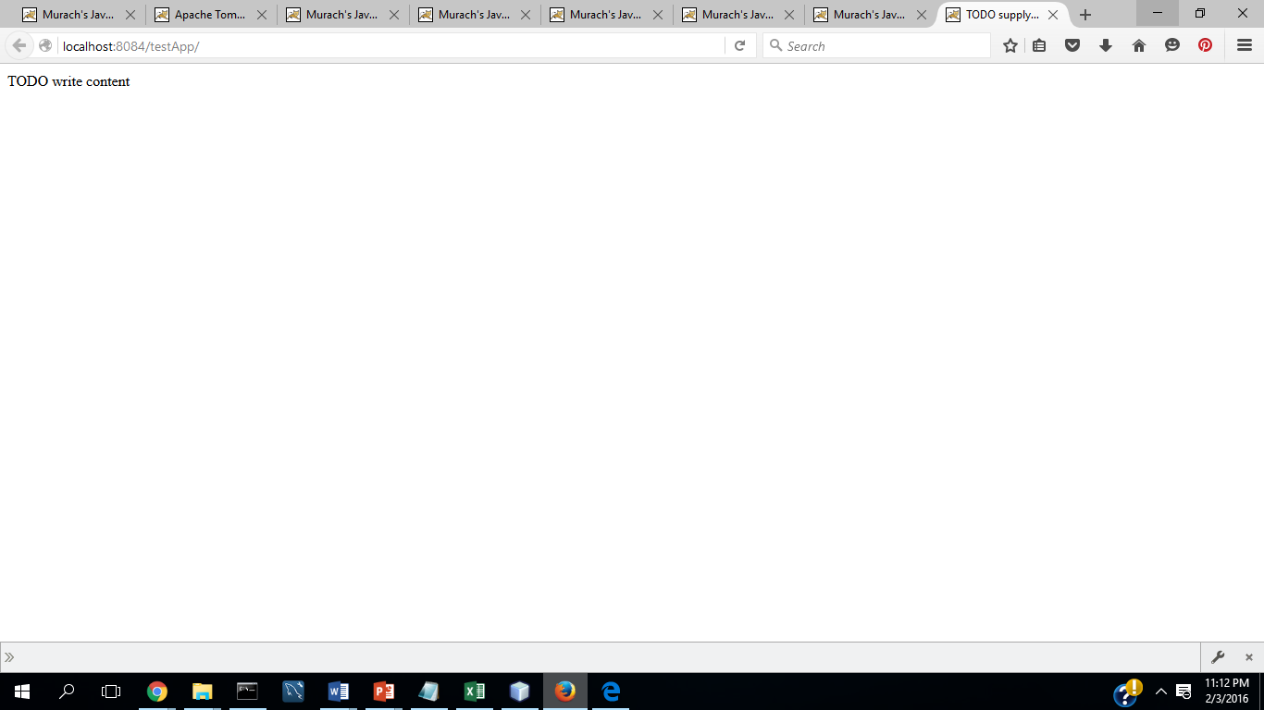

**Add a JSP file to the project.**

1. Add a JSP file named test.jsp to the project. I created the file:

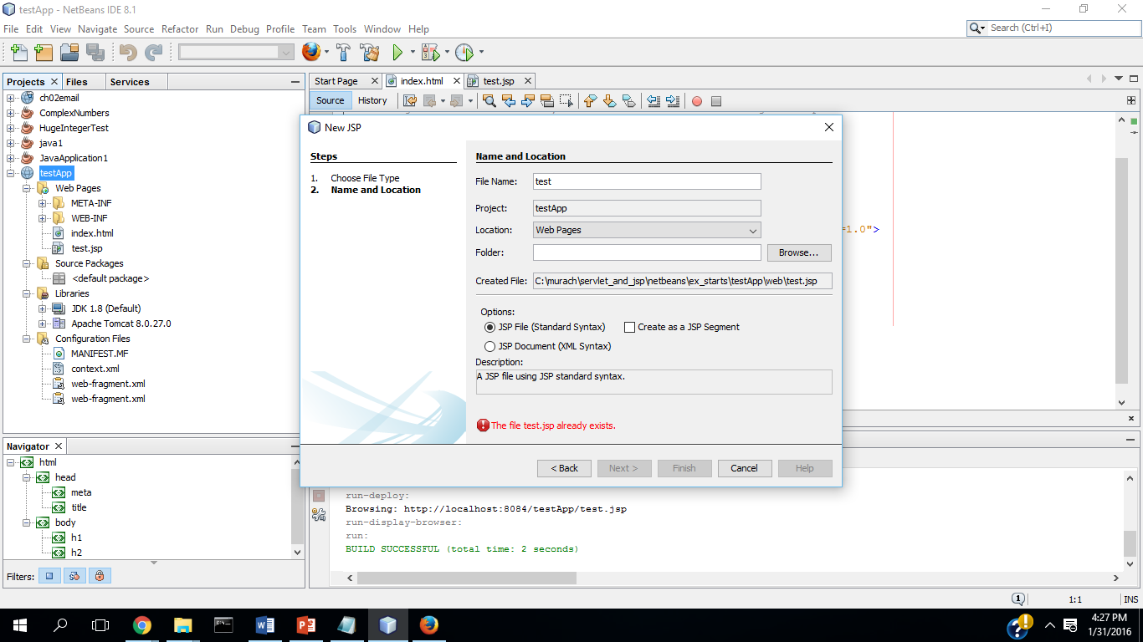

1. Edit the code for the test.jsp file so it includes this tag within its body tags:

<h2>Test JSP</h2>

To do that, type an opening bracket(<), select the h2 tag from the resulting list, and press the Enter key. Next, press the enter key again to complete the tag, and type “Test JSP” within the tag.

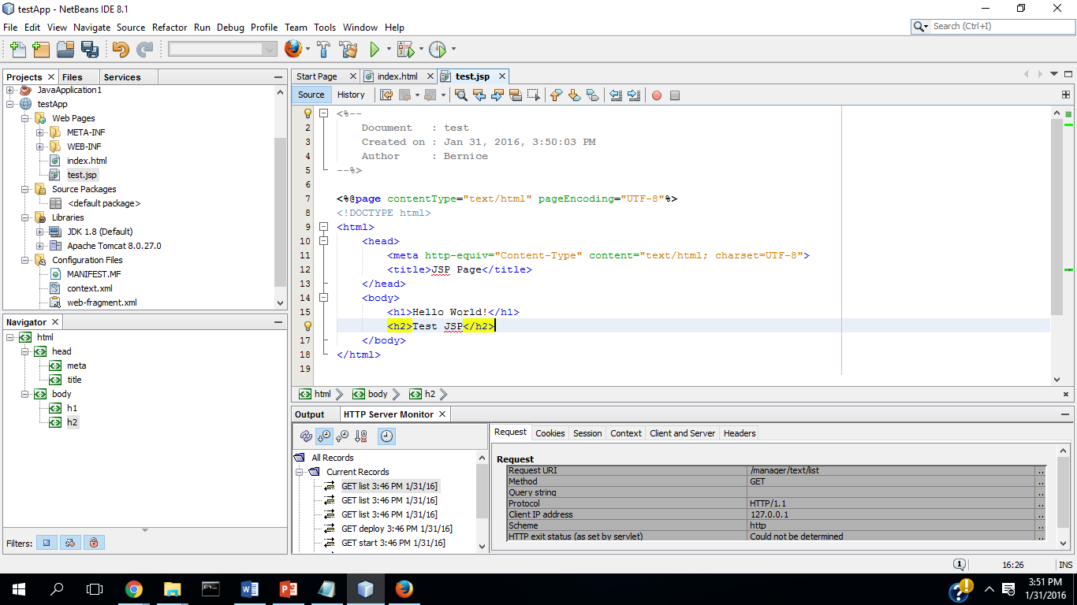

1. Right-click on the test.jsp file in the projects window, and select the Run File command to display this in a browser.

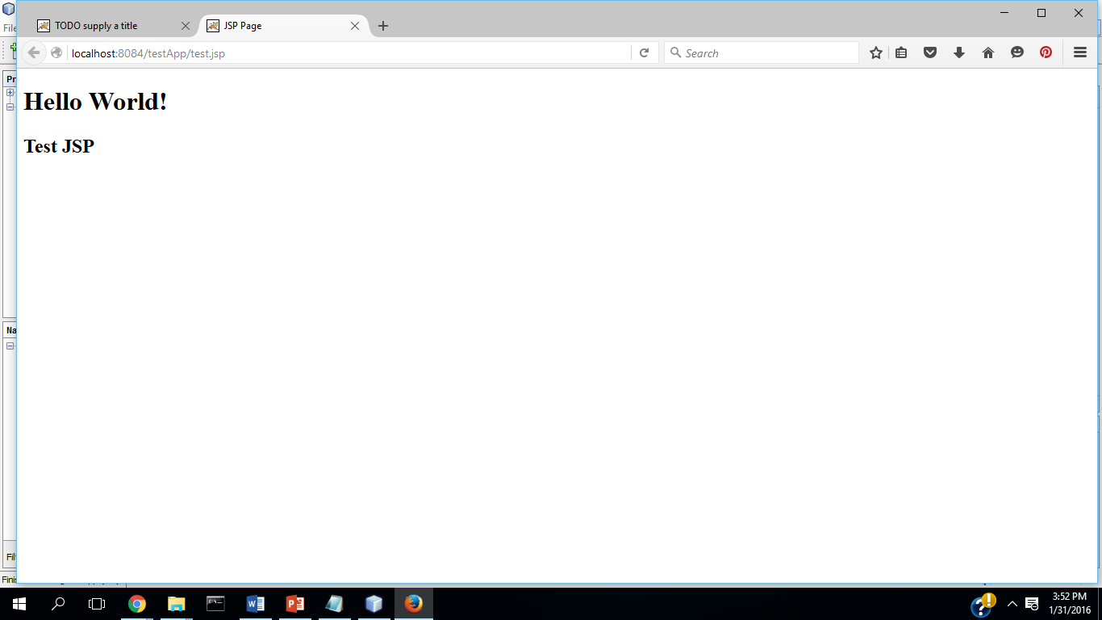

1. Use the Window->IDE Tools->Palette command to open the Palette window, and click on the plus signs for HTML, HTML Forms, and JSP to expand these items. Then, drag the Text Input item to the test.jsp file right after the h2 tag that you entered. In the dialog box that opens, type testName for the Name and click the OK button. Note the HTML tags that are added to the JSP.

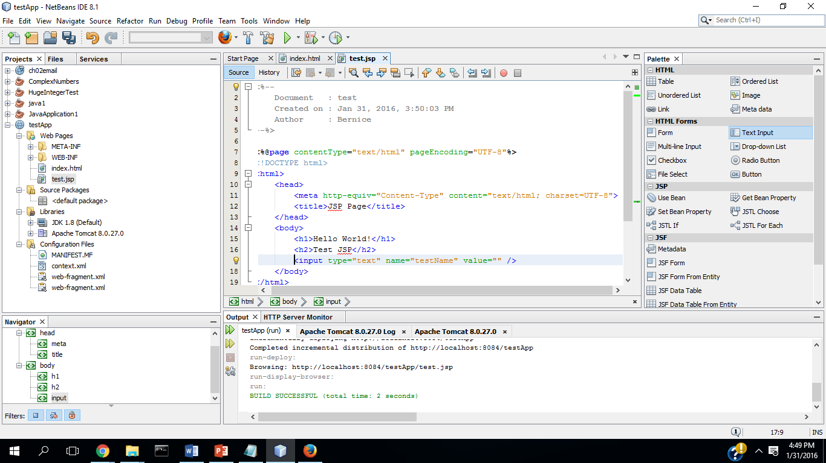

1. Right-click on the test.jsp file, and select the Run File command to display this in a browser.

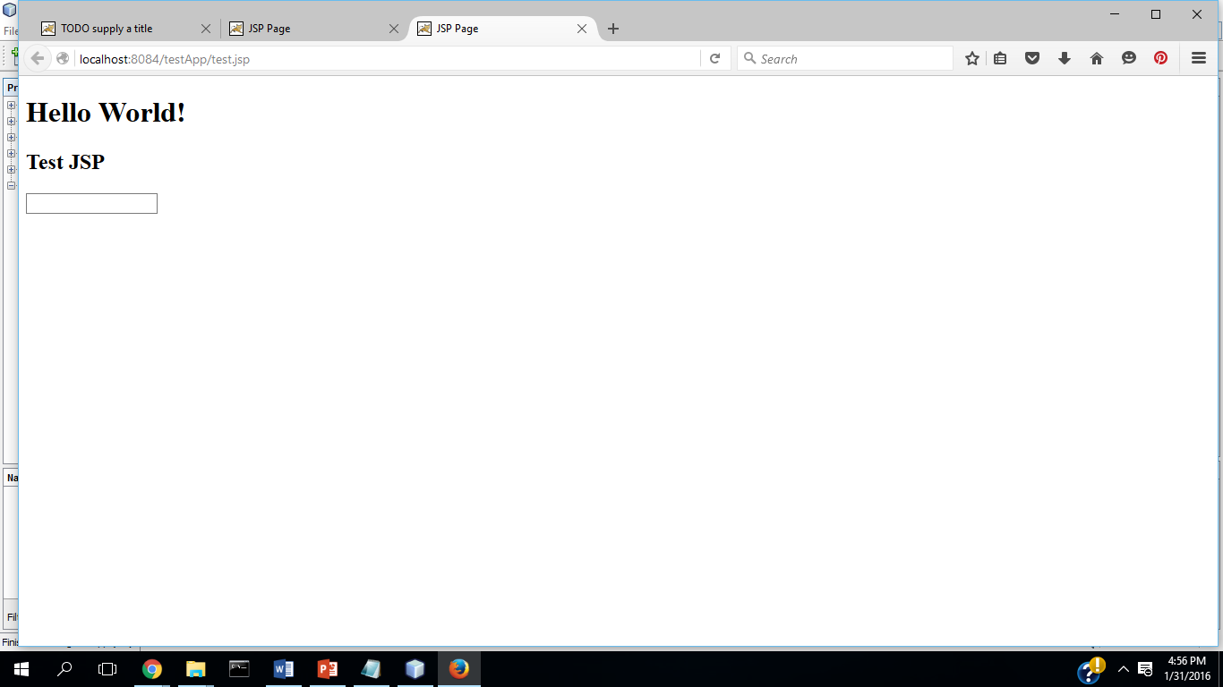

10 Press the F6 button to run the application. Note that the index.html

file runs instead of the test.jsp file, which is usually what you want.

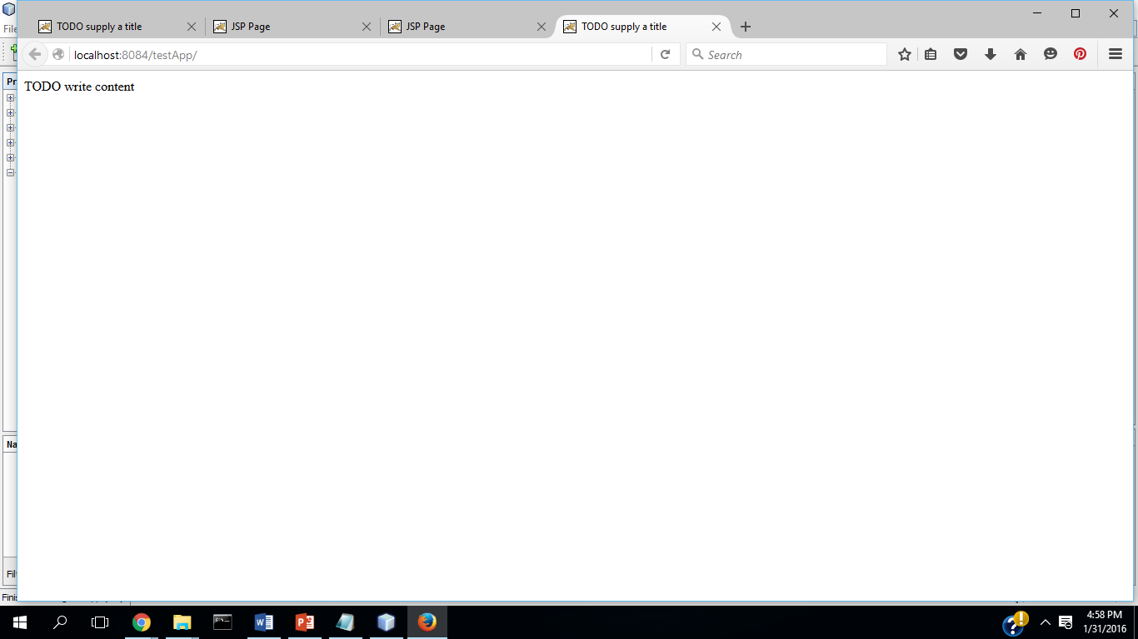

**Add a servlet file to the project**

11. Add a Java servlet named TestServlet to a package named murach.test and map it to the /test URL.

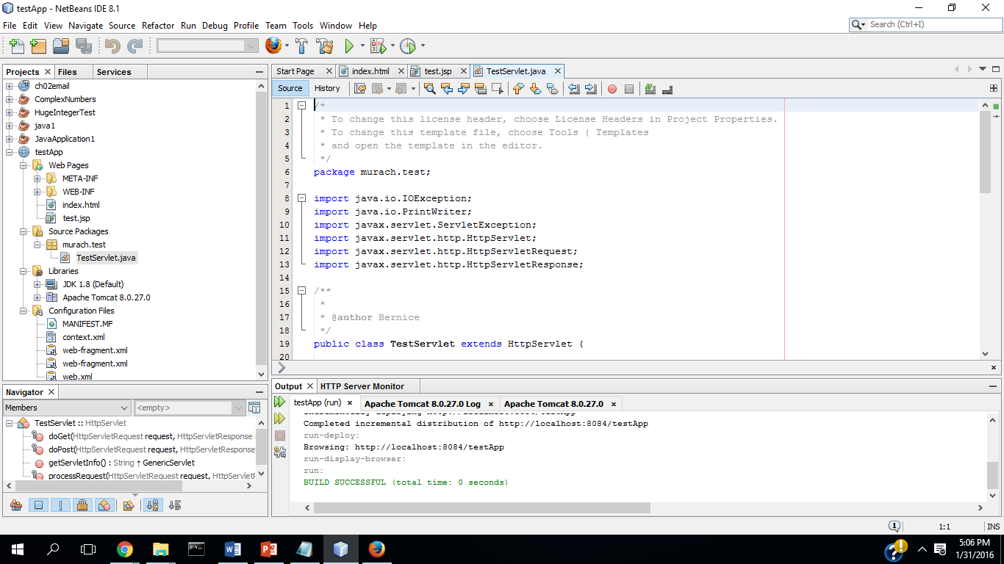

12. In the editor window, scroll to the bottom of the Test Servlet file and click on the + sign before the HttpServlet methods. That should expand the starting code for these methods. Then, note that the doGet and doPost methods call the processRequest method that’s earlier in the servlet.

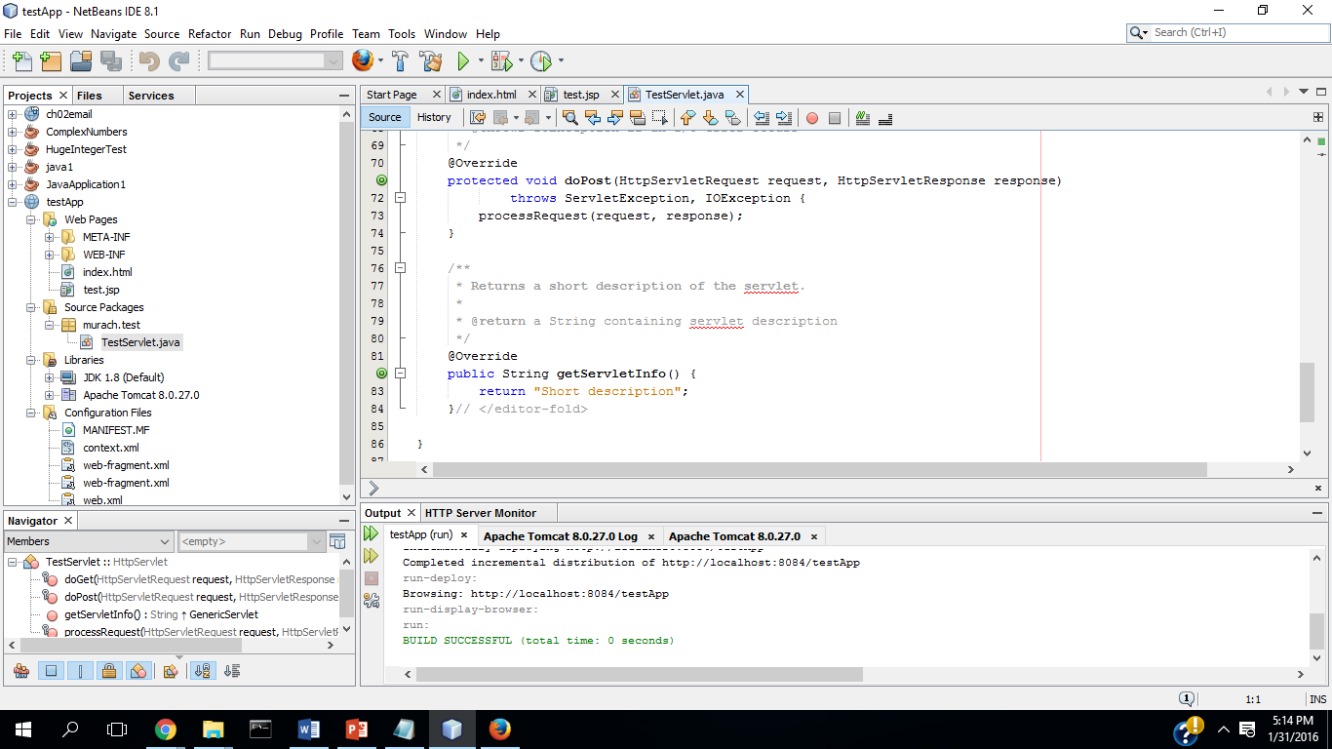

13. In the Projects Window, right-click on the TestServlet file and select the Run File command. In the resulting dialog box, click OK. At this point, NetBeans should display a browser window with some text in it that indicates that the servlet has executed. Note that NetBeans uses the URL that you specified in step 11 to call the servlet.

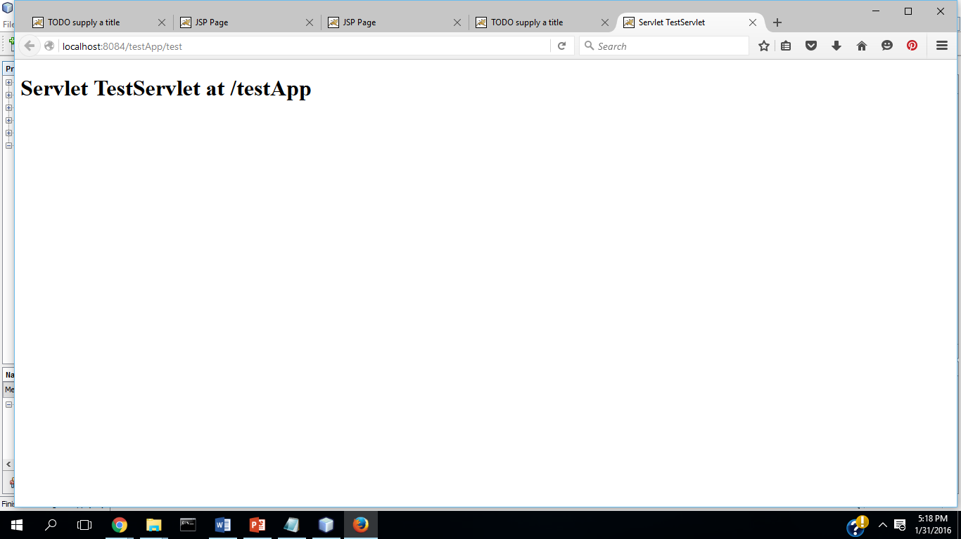

14. Close the testApp project.

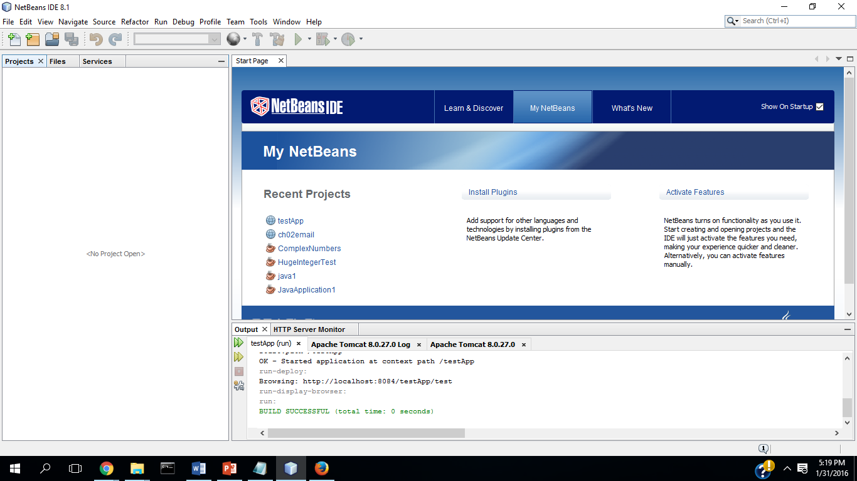

**Exercise 3-2 Experiment with an existing application**

This exercise gives you a chance to run and review one of the applications that has been downloaded from our website.

1. Open the ch02email project in the book_apps directory. Then use the Project window to view the code that’s stored in the HTML, JSP, Java, sevlet, and XML files for this application.

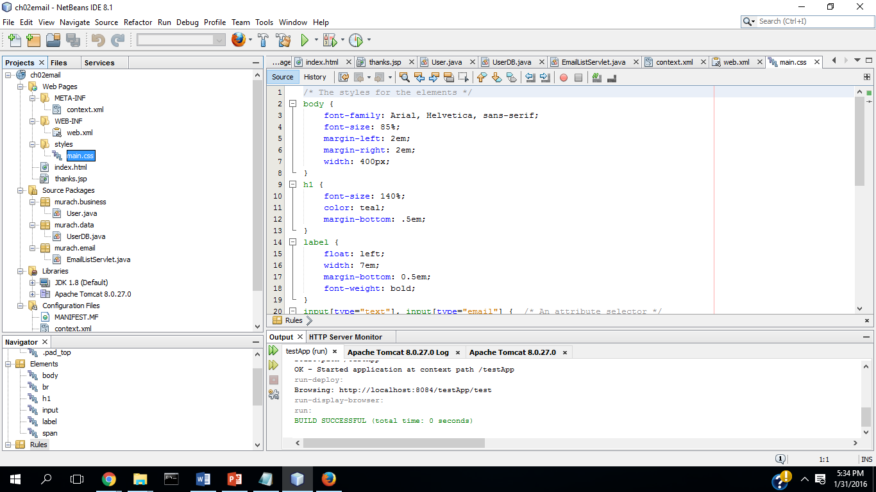

1. Run this application to make sure that it runs correctly on your system. Then enter a first name, last name, and email address into the application and click on the Join Now button. This should display the second page for the application.

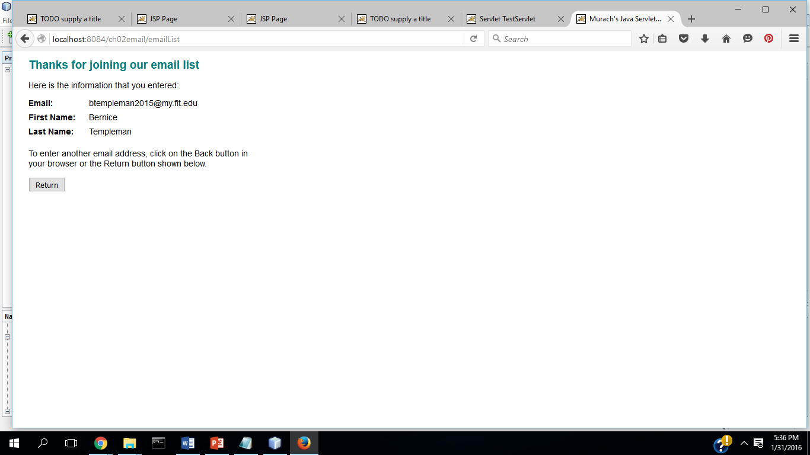

1. Use the Files window to view the files for this application. Note that the web.xml file is stored in the web\WEB-INF folder.

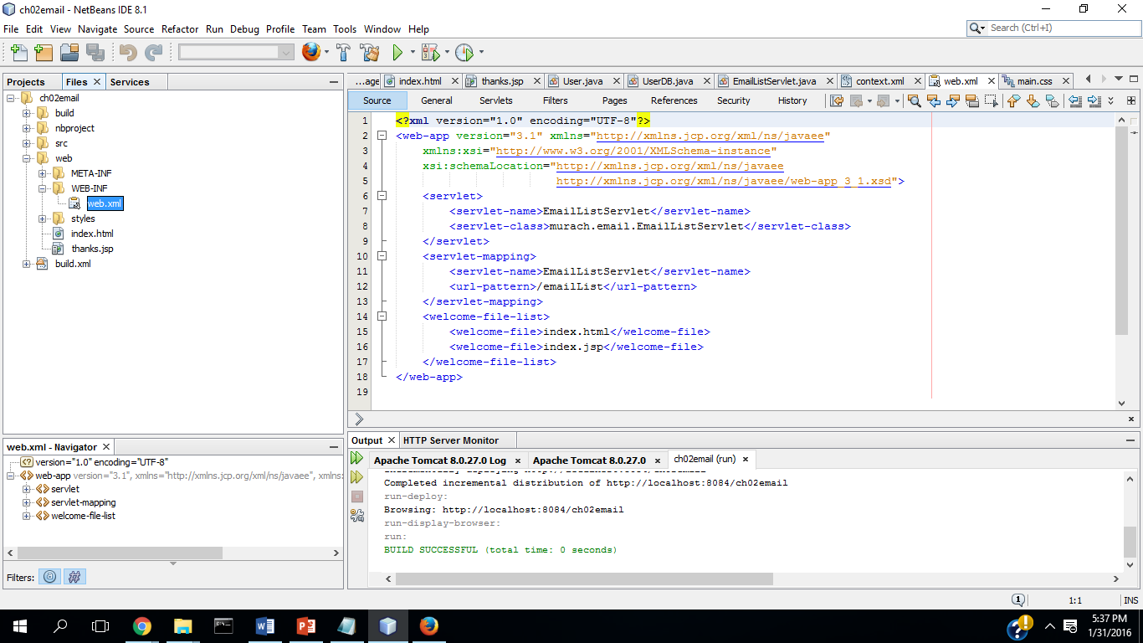

1. Use the Services window to view the applications running on the Tomcat Server.

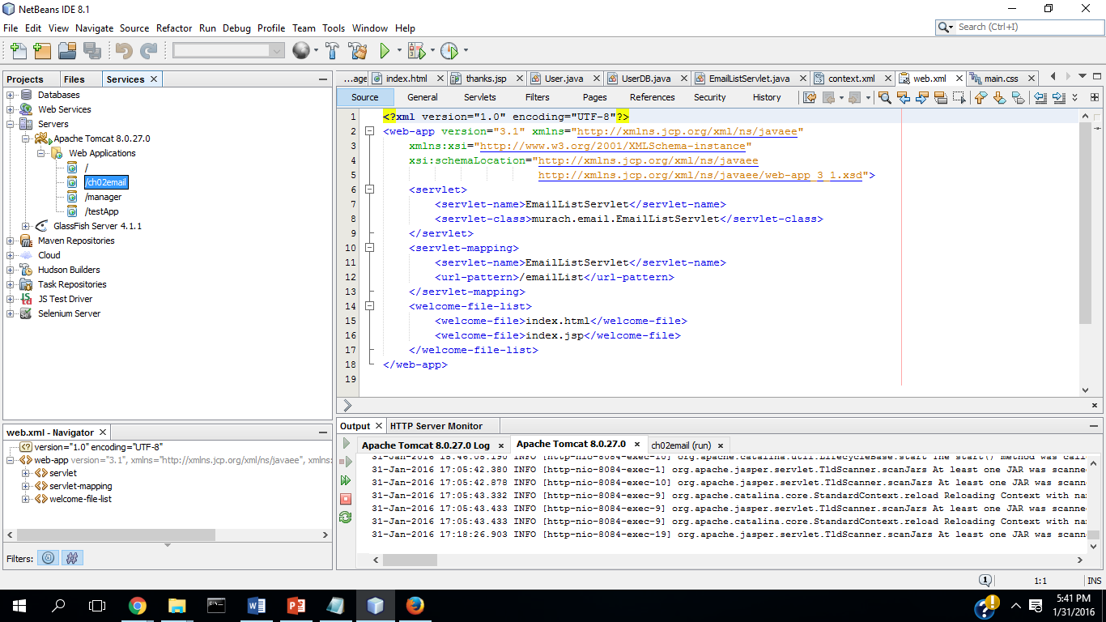

1. Use the Services window to undeploy the ch02email application. To do that, you may need to run NetBeans as administrator.

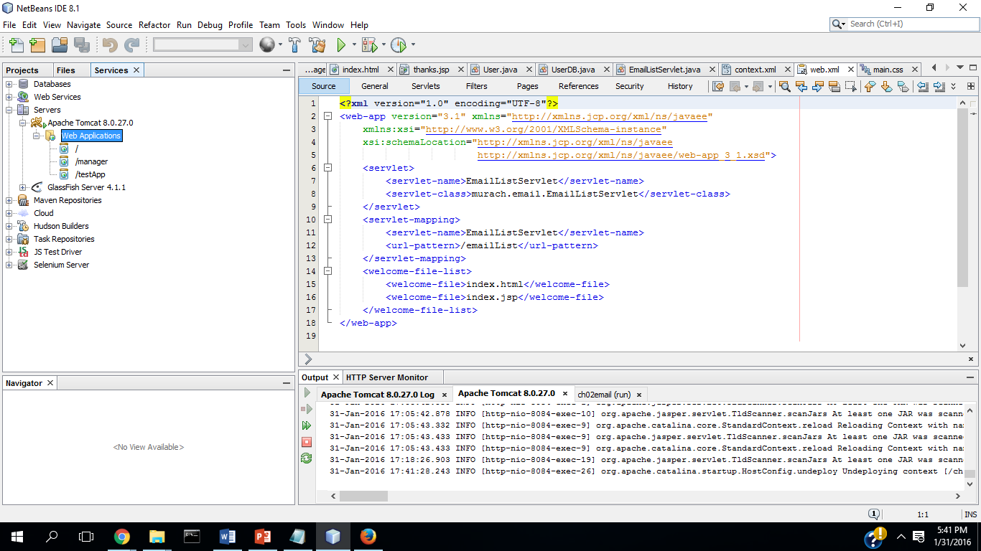

1. Close the ch02email project.

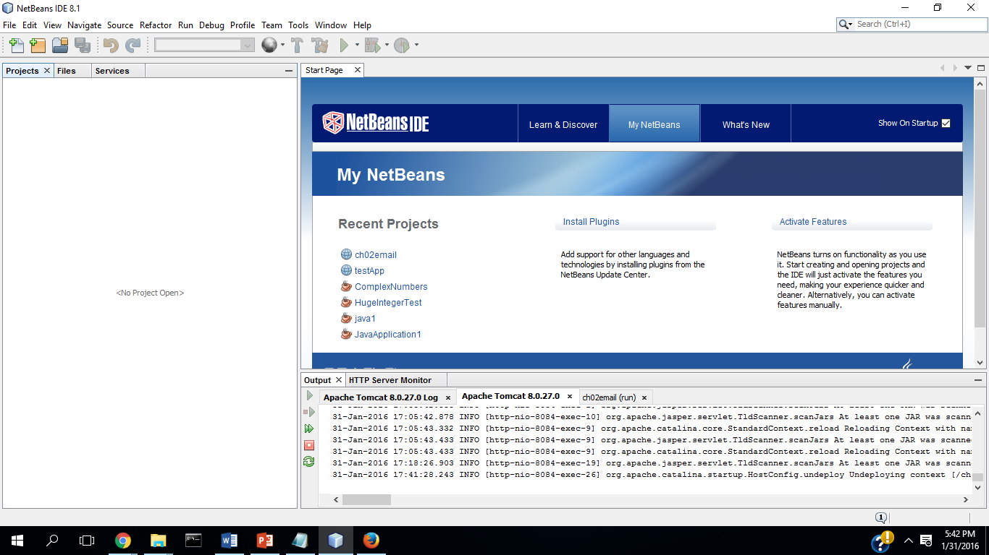

**Exercise 3-3 Run web applications that use a database**

This exercise has you run two of the web applications presented in this book that use a database. This forces you to register the connections for the two databases that are used by this book. For this to work, you must install and configure the MySQL database as described in appendix A(PC).

**Use the murach database**

1. Open the ch12email project that is in the book_apps directory.

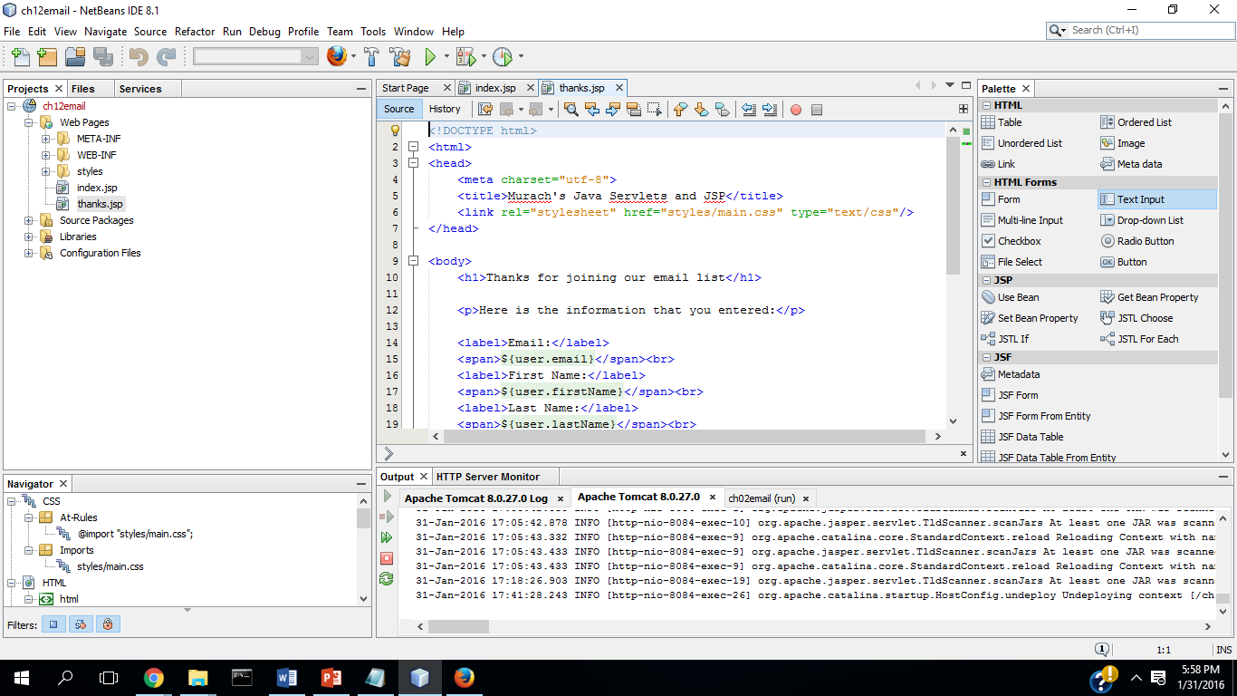

1. If that displays a dialog box that says the database needs to be registered with NetBeans, click on the Close button for this dialog box. Then right-click on the project, select Resolve Data Sources Problem item, and use the resulting dialog boxes to resolve the data source problem and register the database connection for the murach database. Running when not connected to the database generated an error:

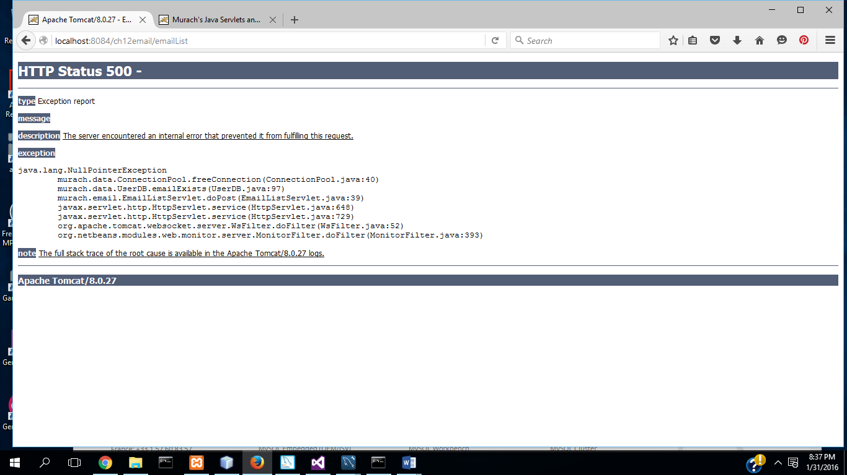

1. Run the application to see how it works. After you enter your name and email address and click on the Join Now button, your entries are saved to a MySQL database.

After connecting the application was successful:

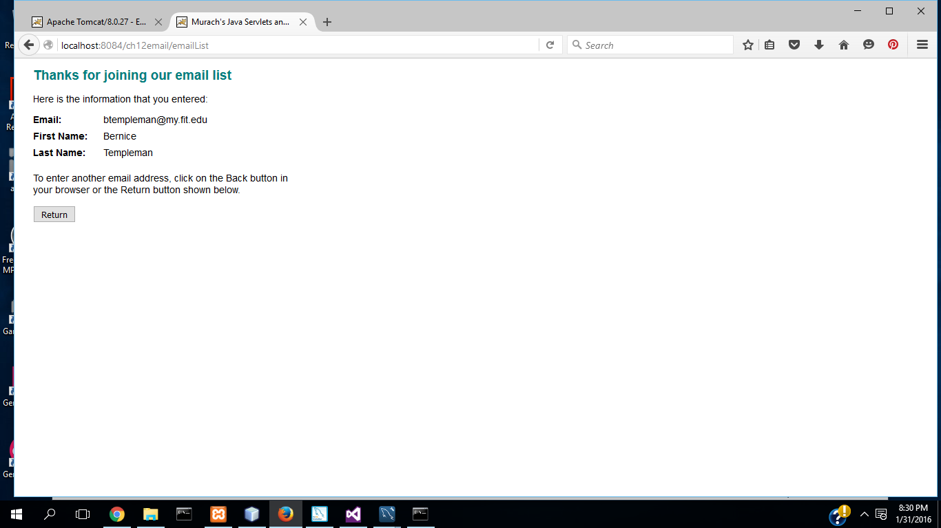

1. Close the project.

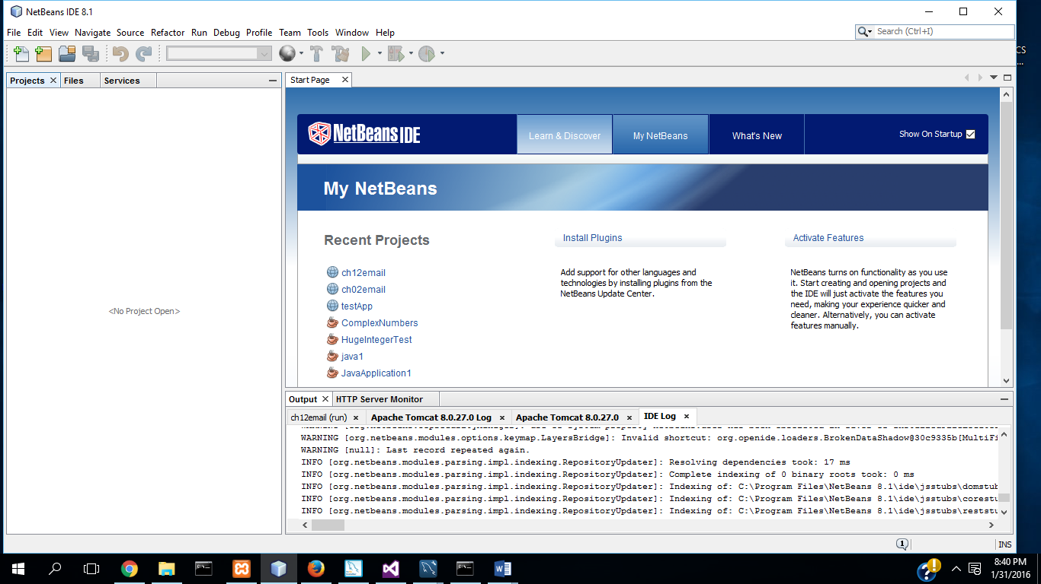

**Use the music database**

1. Open the musicStore application that’s in the book_apps directory.

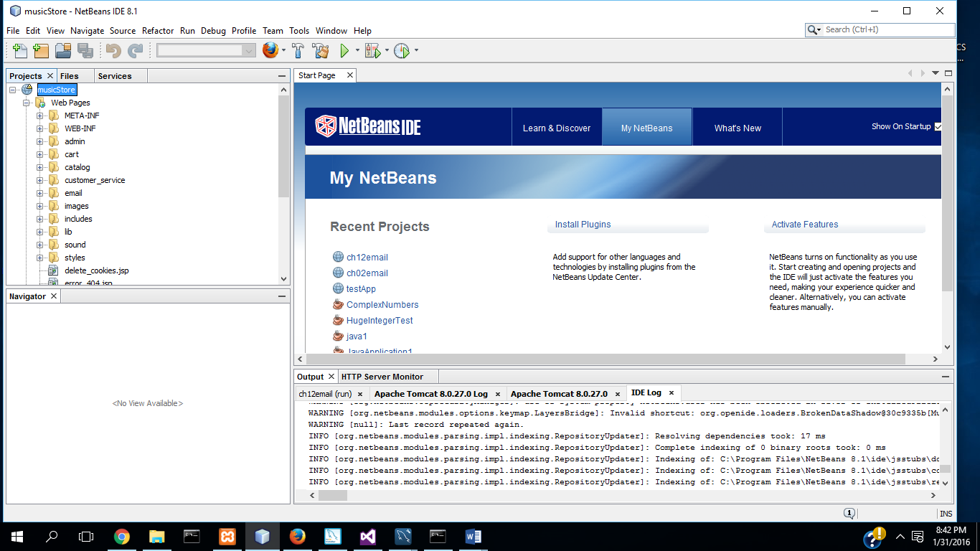

1. If necessary, resolve the data source problem and register the database connection for the music database.

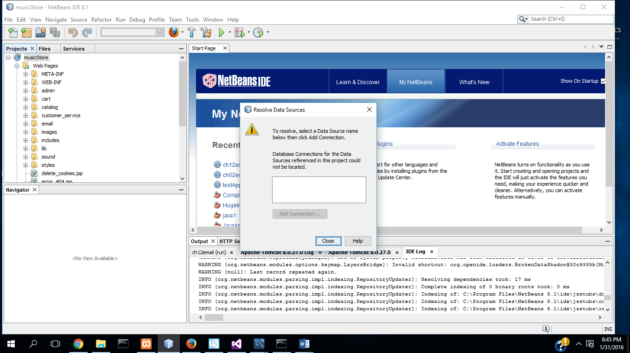

1. Run the application to see how it works. When you browse through the catalog, the application is getting data from a MySQL database.

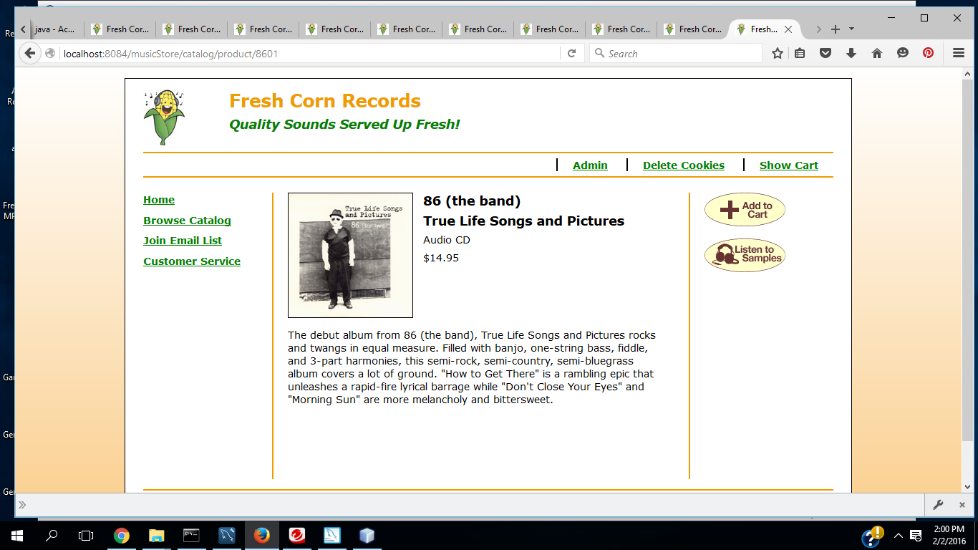

1. Close the project.

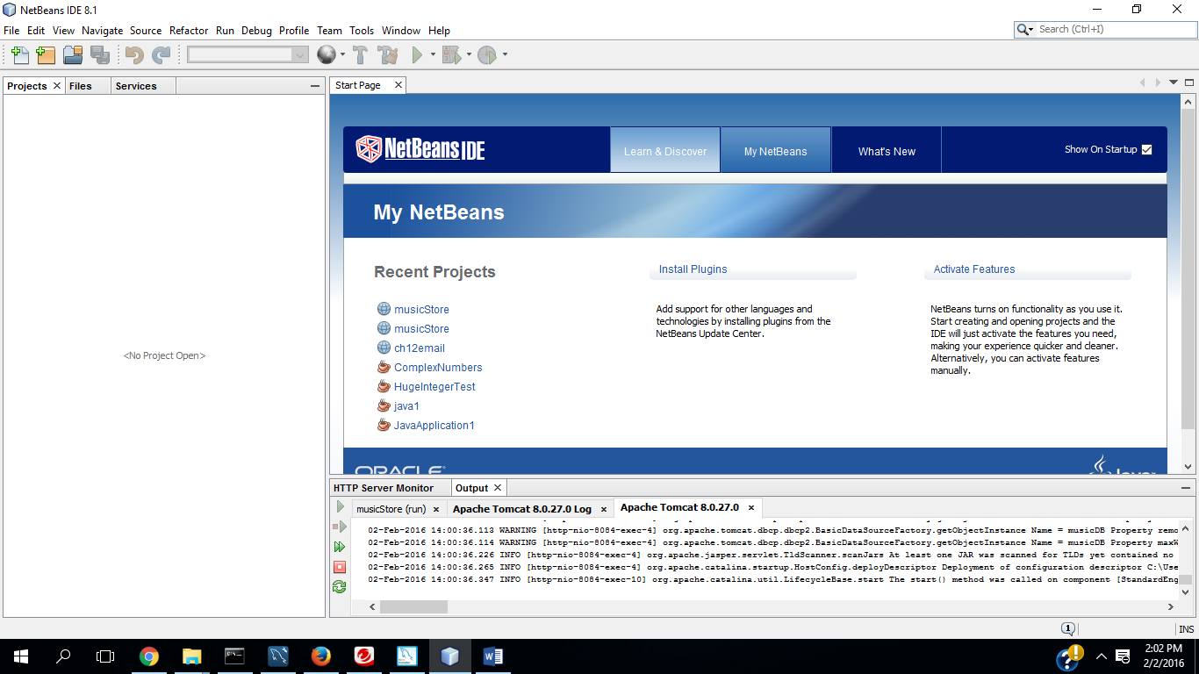

**Were you able to do both parts of this exercise successfully?**

**Yes.**